Manage Courses

On this page, you can view all courses and course sections in your program. You can perform tasks like running reports, adding or dropping students, and deactivating sections. Data on this page updates nightly. Drill into a section to see live data.

You may see various indicators next to course titles. See the [Courseware Flags](https://edmentum.clickhelp.co/articles/courseware-administrator-user-guide/courseware-flags-admin) page to see what each flag means.

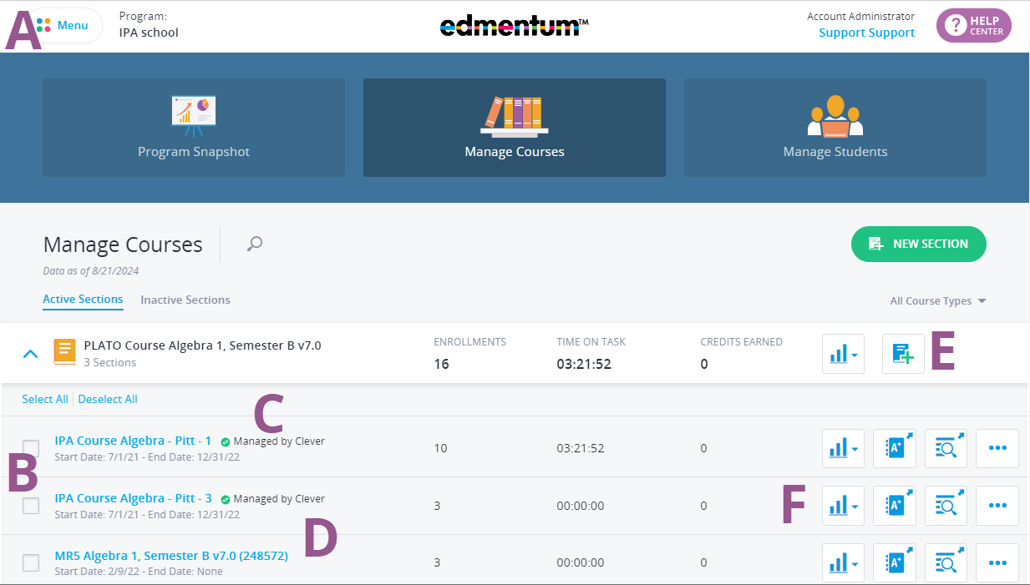

**A**: Open the menu to access the course catalog, reports, custom course builder, instructor pages, and pacing calendar.

**B**: Check the box against a course section to take actions, such as adding students or deactivating the section.

**C**: See at a glance if an integration (ESDE, LTI, Clever, or Classlink) is managing your course sections.

**D**: Select the course section name to view the Section Details page.

**E**: Create a new section of this course.

**F**: Select the icons at the end of the row to create quick reports, open the gradebook, view the curriculum or control section settings/copy the section.